**Rapid Assessment of Competencies for Care of LBW including KMC for Master Trainers for Community Intervention**

Assessment Plan

|  |  |  |  |
| --- | --- | --- | --- |
| **Station** | **Details** | **Marks** | **Observed /Not Observed** |
|  | Checking weight and swaddling a NB (KMC) | **8** | Observed |
|  | Identifying high risk mothers (KMC) | 4 | Unobserved |
|  | Counselling a mother / family member on KMC position and why (KMC) | 8 | Observed |
|  | REST |  |  |
|  | Follow up to be done for LBW (KMC) | 5 | Unobserved |
|  | Checking temperature of a newborn (LBW) | 5 | Observed |
|  | Danger signs (LBW) | 5 | Unobserved |
|  | REST |  |  |
|  | Identification of Still Birth versus Live Birth and Calculation of Gestation Age (KMC) | 8 | Unobserved |
|  | Barriers to KMC (KMC) | 4 | Unobserved |
|  | Expressing breast milk and feeding a newborn with pallada (KMC) | 8 | Observed |
|  | Feeding: Attachment / position (picture) – (LBW) | 5 | Unobserved |
|  | REST |  |  |
|  | TOTAL | 60 |  |

**General instructions to be given by one facilitator to all the participants**

* Each one will go through 10 stations and 3 rest stations
* There are 4 observed and 6 unobserved stations for this rapid exercise
* In the observed station you will be expected to perform some activity. Complete the task within time given
* In the unobserved station you will be asked to write some information on the answer sheet. Write your name on the answer sheet and participant number. Once you complete it fold the answer sheet and place it in the box provided.
* The duration of each station will be 4 minutes
* None of the facilitators will give any comments or assistance
* Three stations have volunteers to help in completing the station
* A bell will ring, each one go to the assigned station based on participant number.
* Do not face the station first
* When the bell rings again, each participant can turn and read participant instructions. Complete the task given.
* If you complete the task before time given, sit in the chair and wait
* When the bell rings again, you must switch to the next station.
* All participants will go through all the stations.
* The rapid exercise will take approximately 50 minutes.
* No one will be allowed to go out of the room during the rapid exercise.

OSCE Overall Evaluation

*: Observed Stations = 38 Unobserved Stations =12

|  |  |  |  |  |  |  |  |  |  |  |  |  |  |
| --- | --- | --- | --- | --- | --- | --- | --- | --- | --- | --- | --- | --- | --- |
| Candidates | **Stations** | | | | | | | | | | | | **Grand**  **Total**  **(60)** |
| **1\*** | **2** | **3\*** | **4** | **5** | **6\*** | **7** | **8** | **9\*** | **10** | **11\*** | **12** |
| **MARKS** | | | | | | | | | | | |
| **(8)** | **(4)** | **(8)** | **(R)** | **(5)** | **(5)** | **(5)** | **(R)** | **(8)** | **(4)** | **(8)** | **(5)** |
| 1. |  |  |  |  |  |  |  |  |  |  |  |  |  |
| 2 |  |  |  |  |  |  |  |  |  |  |  |  |  |
| 3 |  |  |  |  |  |  |  |  |  |  |  |  |  |
| 4 |  |  |  |  |  |  |  |  |  |  |  |  |  |
| 5 |  |  |  |  |  |  |  |  |  |  |  |  |  |
| 6 |  |  |  |  |  |  |  |  |  |  |  |  |  |
| 7 |  |  |  |  |  |  |  |  |  |  |  |  |  |
| 8 |  |  |  |  |  |  |  |  |  |  |  |  |  |
| 9 |  |  |  |  |  |  |  |  |  |  |  |  |  |
| 10 |  |  |  |  |  |  |  |  |  |  |  |  |  |
| 11 |  |  |  |  |  |  |  |  |  |  |  |  |  |
| 12 |  |  |  |  |  |  |  |  |  |  |  |  |  |

**Spread of Stations as per Themes**

* **KMC:**  Stations 1, 2, 3, 5, 10, 11 = 38
* **Care of LBW:** Stations 6, 7, 12 = 14
* **Supervision/Teaching:** Stations 9 = 8

**Requirements for Each Rapid Assessment Station**

|  |  |  |
| --- | --- | --- |
| **General requirements**   * Juice for volunteers and faculty * Snacks * Cellotape | * Instructions for each station * Files to place the Key for each station – 10 * Bell, stopwatch | |
| **Station 1: Checking the Weight and Swaddling a new-born**   * Mannequin - * One baby sheet/ towel * Cotton swab with spirit * Weighing machine * Kidney tray * Chit of paper to record weight of mannequin * Key for scoring candidate * Table (1) / Chairs (2) * Volunteer / Observer to act as a nurse | | **Station 2: Identifying High Risk Mothers**   * Table (1) / Chair -1 * Case scenario * Answer sheet for each candidate to fill in the answer * Key for scoring candidate |
| **Station 3: Counseling a Mother / Care Taker on KMC Position and Why**   * Baby- Preminatalie * Dupatta / KMC bag * Chair (2) / Table (1) Optional * Volunteer / Observer to act as a mother * Key for scoring candidate | | **Station 4: REST**   * Chair (1) / Table optional (1)   **Station 5: Follow up to be done for a LBW baby on KMC**   * Key for scoring candidate * Answer sheet * Table-1 / Chair-2 * Case scenarios |
| **Station 6: Checking Temperature of a New-born**   * Mannequin * Thermometer * Spirit swab * Kidney tray * Container to keep thermometer in after completing the procedure * Alcohol rub solution * Chair (2) / Table/couch * Key for scoring candidate | | **Station 7: Danger Signs of a Newborn**   * Laminated pictures of danger signs  1. Cyanosis or blue baby 2. Skin pustules 3. Stiff baby 4. Jaundice (both) 5. Case scenario  * Answer sheet for each candidate * Key for scoring candidate * Table –(1) / Chair -1 |
| **Station 8: REST**   * Chair (1) / Table optional (1)   **Station 9: Identification of Still Birth versus Live Birth and Calculation of Gestational Age**   * Chair (1) / Table (1) Optional * Answer sheetsr | | **Station 10: Ways to Address Barriers to KMC**   * Case Scenario * Chair - 1 * Table -1 * Key for scoring candidate |
| **Station 11. Expression of Breast Milk and Feeding a Newborn by Pallada**   * Breast milk model * Pallada * Mannequin * Container to store breast milk * Alcohol hand scrub * Key for scoring candidate * Table-(1) / Chair-1 | | **Station 12: Breast feeding –Position and Attachment**   * Laminated picture for position and attachment * Answer Sheet for participants * Scoring key   **Station 13: REST**   * Chair (1) / Table optional (1) |

**OSCE Station 1:**

**Checking Weight and Swaddling a Newborn**

1. Demonstrate
   * 1. checking weight of newborn mannequin.
     2. swaddling of the newborn mannequin.

**Key for Station 1: Checking Weight and Swaddling a Newborn (8)**

|  |  |  |  |  |  |  |  |  |  |  |  |  |
| --- | --- | --- | --- | --- | --- | --- | --- | --- | --- | --- | --- | --- |
|  |  |  |  |  |  |  |  |  |  |  |  |  |
| **S. NO** | **Observations** | **Mark** | **1** | **2** | **3** | **4** | **5** | **6** | **7** | **8** | **9** | **10** |
|  | Cleans the tray/pan / weighing bag with spirit swab or soap and water soaked cotton swab or gauze. Then clean with a dry swab | **0.5** |  |  |  |  |  |  |  |  |  |  |
| 2 | Places clean cloth over the tray / pan / bag of weighing scale in centre | **0.5** |  |  |  |  |  |  |  |  |  |  |
| 3 | Sets the weighing scale to zero   * adjusts knob so that reading is zero in beam scale * allows the digital scale to adjust to zero automatically or uses the knob | **0.5x2=1.0** |  |  |  |  |  |  |  |  |  |  |
| 4. | Uses alcohol hand rub/washes hand thoroughly | **0.5** |  |  |  |  |  |  |  |  |  |  |
| 5 | Removes all clothes of the baby except napkin | **0.5** |  |  |  |  |  |  |  |  |  |  |
| 6 | Places the mannequin/baby in the centre of the tray / pan / bag | **1.0** |  |  |  |  |  |  |  |  |  |  |
| 7 | Notes and records the weight accurately.  waits till the needle / marker is more or less stable   * notes the reading on the scale to the nearest 0.01kg * waits till the number displayed is more or less stable, freeze the reading | **1.0** |  |  |  |  |  |  |  |  |  |  |
| 8 | Swaddles the baby correctly:   * Puts clothes on – cap, socks, mitten and dress * Folds one corner of the sheet * Places the mannequin on the sheet with head on the folded part * Wraps the side over the abdomen and under the opposite side. * Does the same for the other side * Tucks the middle portion on top. | **0.5X7- 3.5** |  |  |  |  |  |  |  |  |  |  |
|  | TOTAL | **8.0** |  |  |  |  |  |  |  |  |  |  |

**OSCE Station 2:**

**Identifying High Risk Mothers**

Some women are at high risk for giving birth to a low birth weight baby or preterm baby.

Look at the pictures and write what is the high risk you can see in the mother.

PICTURE 1

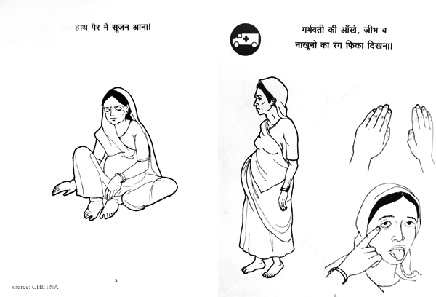

PICTURE 2

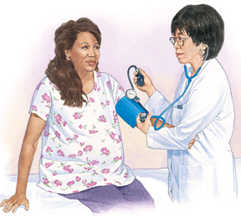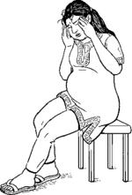

PICTURE 3

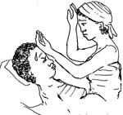

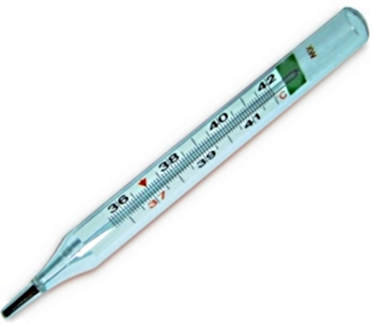

PICTURE 4

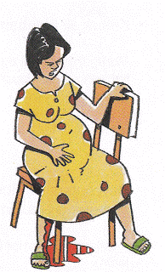

**Key for Station 2: Identifying High Risk Mothers for LBW (4)**

|  |  |  |  |  |  |  |  |  |  |  |  |  |  |  |
| --- | --- | --- | --- | --- | --- | --- | --- | --- | --- | --- | --- | --- | --- | --- |
|  |  |  | **Participants** | | | | | | | | | | | |
| **S. NO** | **Observations** | **Mark** | **1** | **2** | **3** | **4** | **5** | **6** | **7** | **8** | **9** | **10** | **11** | **12** |
| **1** | **Picture 1 – Anemia** | **1** |  |  |  |  |  |  |  |  |  |  |  |  |
| **2** | **Picture 2 – High BP, headache** | **1** |  |  |  |  |  |  |  |  |  |  |  |  |
| **3.** | **Fever** | **1** |  |  |  |  |  |  |  |  |  |  |  |  |
| **4.** | **Bleeding** | **1** |  |  |  |  |  |  |  |  |  |  |  |  |
|  | **TOTAL** | **4** |  |  |  |  |  |  |  |  |  |  |  |  |

**Key for Station 2: Identifying High Risk Mothers for LBW (4)**

|  |  |  |  |  |  |  |  |  |  |  |  |  |  |  |
| --- | --- | --- | --- | --- | --- | --- | --- | --- | --- | --- | --- | --- | --- | --- |
|  |  |  | **Participants** | | | | | | | | | | | |
| **S. NO** | **Observations** | **Mark** | **13** | **14** | **15** | **16** | **17** | **18** | **19** | **20** | **21** | **22** | **23** | **24** |
| **1** | **Picture 1 – Anemia** | **1** |  |  |  |  |  |  |  |  |  |  |  |  |
| **2** | **Picture 2 – High BP, headache** | **1** |  |  |  |  |  |  |  |  |  |  |  |  |
| **3.** | **Fever** | **1** |  |  |  |  |  |  |  |  |  |  |  |  |
| **4.** | **Bleeding** | **1** |  |  |  |  |  |  |  |  |  |  |  |  |
|  | **TOTAL** | **4** |  |  |  |  |  |  |  |  |  |  |  |  |

**OSCE Station 3**

**Counselling a Mother / Care Taker on KMC Position and Why**

Ms Asha has a 1800gm baby that is stable. You have to counsel her to start KMC.

Demonstrate how you would counsel her on providing KMC.

**OSCE Station 4 – REST**

**Key for Station 3: Counselling a Mother / Care Taker on KMC Position and Why**

|  |  |  |  |  |  |  |  |  |  |  |  |  |
| --- | --- | --- | --- | --- | --- | --- | --- | --- | --- | --- | --- | --- |
|  |  |  | **PARTICIPANTS S. NO** | | | | | | | | | |
| **S. NO** | **Observations** | **Marks** | **1** | **2** | **3** | **4** | **5** | **6** | **7** | **8** | **9** | **10** |
|  | Introduces self and calls her by name | **0.5** |  |  |  |  |  |  |  |  |  |  |
|  | Explains the need for KMC, benefit | **0.5x4=**  **2.0** |  |  |  |  |  |  |  |  |  |  |
|  | Demonstrates KMC for the mother volunteer after checking what she is comfortable to use | **0.5x2=**  **1.0** |  |  |  |  |  |  |  |  |  |  |
|  | Asks the mother what would help her to give KMC | **1.0** |  |  |  |  |  |  |  |  |  |  |
|  | Asks the mother what would prevent her from giving KMC | **0.5x2=1** |  |  |  |  |  |  |  |  |  |  |
|  | Mother demonstrates how to position newborn for KMC | **0.5** |  |  |  |  |  |  |  |  |  |  |
|  | Has a good rapport | **1.0** |  |  |  |  |  |  |  |  |  |  |
|  | Recollects the information shared | **1.0** |  |  |  |  |  |  |  |  |  |  |
|  | TOTAL | **8** |  |  |  |  |  |  |  |  |  |  |

**Key for Station 3: Counselling a Mother / Care Taker on KMC**

|  |  |  |  |  |  |  |  |  |  |  |  |  |
| --- | --- | --- | --- | --- | --- | --- | --- | --- | --- | --- | --- | --- |
|  |  |  | **PARTICIPANTS S. NO** | | | | | | | | | |
| **S. NO** | **Observations** | **Marks** | **11** | **12** | **13** | **14** | **15** | **16** | **17** | **18** | **19** | **20** |
|  | Introduces self and calls her by name | **0.5** |  |  |  |  |  |  |  |  |  |  |
|  | Explains the need for KMC, benefit | **0.5x4=**  **2.0** |  |  |  |  |  |  |  |  |  |  |
|  | Demonstrates KMC for the mother volunteer after checking what she is comfortable to use | **0.5x2=**  **1.0** |  |  |  |  |  |  |  |  |  |  |
|  | Asks the mother what would help her to give KMC | **1.0** |  |  |  |  |  |  |  |  |  |  |
|  | Asks the mother what would prevent her from giving KMC | **0.5x2=1** |  |  |  |  |  |  |  |  |  |  |
|  | Mother demonstrates how to position newborn for KMC | **0.5** |  |  |  |  |  |  |  |  |  |  |
|  | Has a good rapport | **1.0** |  |  |  |  |  |  |  |  |  |  |
|  | Recollects the information shared | **1.0** |  |  |  |  |  |  |  |  |  |  |
|  | TOTAL | **8** |  |  |  |  |  |  |  |  |  |  |

**OSCE Station 5**

**Follow up Visit of LBW Baby**

**Name:**

When you visit a mother of a LBW baby at home, which of the following must be assessed during a follow up visit to make sure the baby is doing well.

Circle the serial no (S.NO) of the correct responses.

**OSCE Station 5**

**Follow up Visit of LBW Baby**

**Answer Sheet**

**Name:**

|  |  |
| --- | --- |
| S. No |  |
| 1 | Check the weight of the baby |
| 2 | Check if mother is eating well |
| 3. | Check if the mother is giving KMC and the duration of it |
| 4. | Check if the baby active / alert when awake |
| 5. | Check if the mother is taking Iron and Folic acid tablets |
| 6. | Check if the mother has danger signs |
| 7. | Check if the baby has any danger signs |
| 8 | Counsel on how to overcome any difficulties to practice KMC |
| 9 | Check if there are breast feeding difficulties from the mother’s side |
| 10. | Check if the baby is having exclusive breast milk as feed |

**Key for Station 5: Follow up of a Low Birth Weight Baby**

|  |  |  |  |  |  |  |  |  |  |  |  |  |  |  |
| --- | --- | --- | --- | --- | --- | --- | --- | --- | --- | --- | --- | --- | --- | --- |
|  |  |  | **Participants Serial No.** | | | | | | | | | | | |
| **S. NO** | **Observations** | **Marks** | **1** | **2** | **3** | **4** | **5** | **6** | **7** | **8** | **9** | **10** | **11** | **12** |
|  | Check the weight of the baby | **1** |  |  |  |  |  |  |  |  |  |  |  |  |
|  | Check if the mother is giving KMC and the duration of it | **1** |  |  |  |  |  |  |  |  |  |  |  |  |
|  | Check if the baby active / alert when awake | **1** |  |  |  |  |  |  |  |  |  |  |  |  |
|  | Check if the baby has danger signs | **1** |  |  |  |  |  |  |  |  |  |  |  |  |
|  | Check if there are breast feeding difficulties from the mother’s side | **1** |  |  |  |  |  |  |  |  |  |  |  |  |
|  | TOTAL | **5** |  |  |  |  |  |  |  |  |  |  |  |  |

**Key for Station 5: Follow up of a Low Birth Weight Baby**

|  |  |  |  |  |  |  |  |  |  |  |  |  |  |  |
| --- | --- | --- | --- | --- | --- | --- | --- | --- | --- | --- | --- | --- | --- | --- |
|  |  |  | **Participants Serial No.** | | | | | | | | | | | |
| **S. NO** | **Observations** | **Marks** | **13** | **14** | **15** | **16** | **17** | **18** | **19** | **20** | **21** | **22** | **23** | **24** |
|  | Check the weight of the baby | **1** |  |  |  |  |  |  |  |  |  |  |  |  |
|  | Check if the mother is giving KMC and the duration of it | **1** |  |  |  |  |  |  |  |  |  |  |  |  |
|  | Check if the baby active / alert when awake | **1** |  |  |  |  |  |  |  |  |  |  |  |  |
|  | Check if the baby has danger signs | **1** |  |  |  |  |  |  |  |  |  |  |  |  |
|  | Check if there are breast feeding difficulties from the mother’s side | **1** |  |  |  |  |  |  |  |  |  |  |  |  |
|  | TOTAL | **8** |  |  |  |  |  |  |  |  |  |  |  |  |

**OSCE Station 6**

**Checking Temperature of a Newborn**

Demonstrate how you will check temperature for a newborn.

**Key for Station 6: Checking Temperature of a New-born**

|  |  |  |  |  |  |  |  |  |  |  |  |  |  |  |
| --- | --- | --- | --- | --- | --- | --- | --- | --- | --- | --- | --- | --- | --- | --- |
|  |  |  | **Participants** | | | | | | | | | | | |
| **S. NO** | **Records the following on the case sheet** | **Marks** | **1** | **2** | **3** | **4** | **5** | **6** | **7** | **8** | **9** | **10** | **11** | **12** |
| 1 | Collects the articles/supplies-thermometer, cotton swab with spirit, dry cotton balls | **0.5** |  |  |  |  |  |  |  |  |  |  |  |  |
| 2 | Wipes thermometer with dry cotton from bulb to stem | **0.5** |  |  |  |  |  |  |  |  |  |  |  |  |
| 3 | Checks the reading of thermometer, shakes it so that mercury level is below the lowest temperature recording | **0.5** |  |  |  |  |  |  |  |  |  |  |  |  |
| 4 | Places the thermometer horizontal to body of the baby mannequin in arm pit, so that bulb is in close skin contact. Hold the arm close to the body | **0.5** |  |  |  |  |  |  |  |  |  |  |  |  |
| 5 | Keeps the thermometer in place for 3 minutes. | **0.5** |  |  |  |  |  |  |  |  |  |  |  |  |
| 6 | Removes thermometer, wipes the thermometer with spirit cotton swab from stem to bulb and then with dry cotton swab. | **0.5** |  |  |  |  |  |  |  |  |  |  |  |  |
| 7 | Checks the reading of thermometer holding it at eye level and rotating it so that the mercury level is clearly visible | **1.0** |  |  |  |  |  |  |  |  |  |  |  |  |
| 8 | Informs the observer the temperature | **1.0** |  |  |  |  |  |  |  |  |  |  |  |  |
|  | **TOTAL** | **5** |  |  |  |  |  |  |  |  |  |  |  |  |

**OSCE Station 7**

**Name the Danger Sign**

There are 5 different pictures. Each picture shows a new-born presenting with a danger sign (Picture No 1-5).

Identify from the picture the danger sign. Write the answer in the blank given against each question number (1-5).

**Picture 1**

**Q1: What is the Danger Sign?**

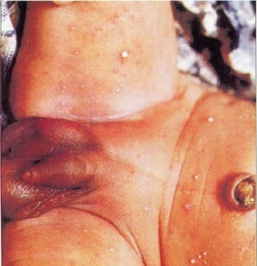

**Picture 2**

**Q2: What is the Danger Sign?**

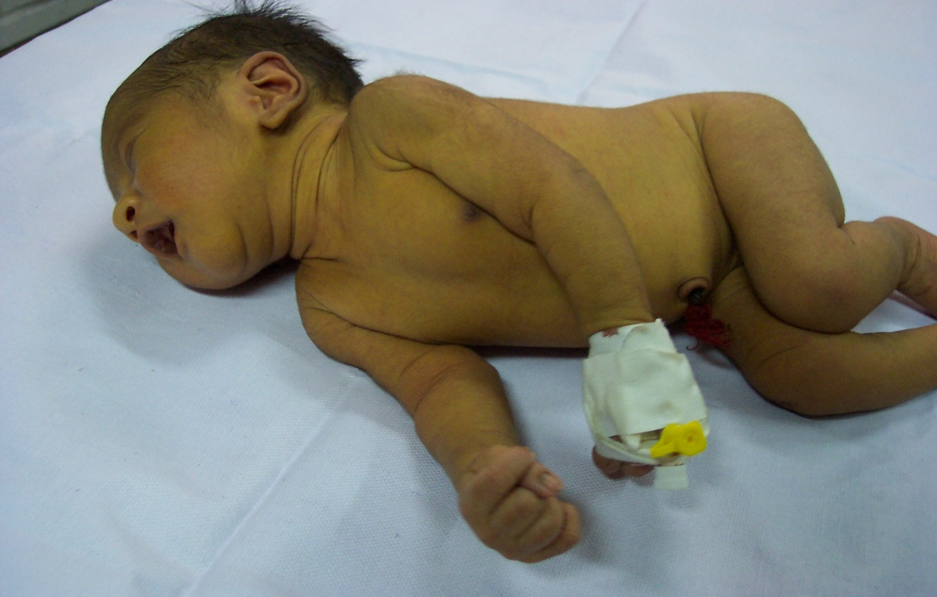

**Picture 3**

**Q3: What is the Danger Sign?**

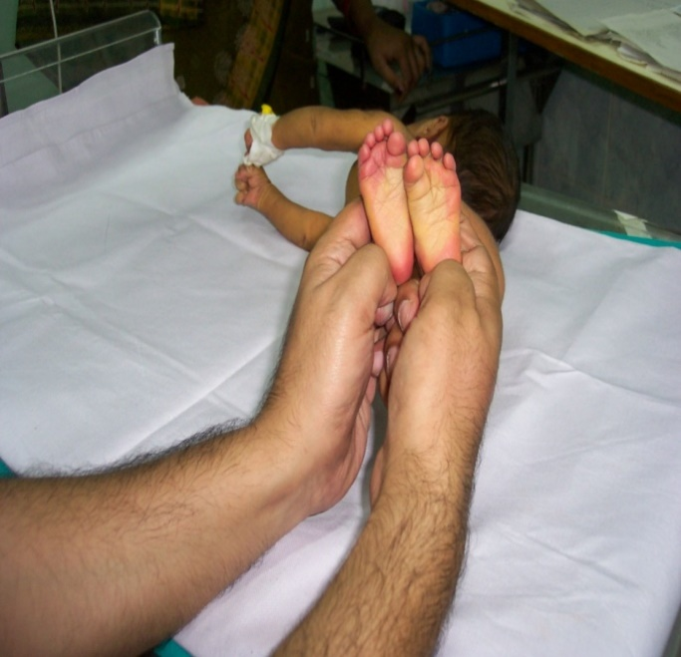

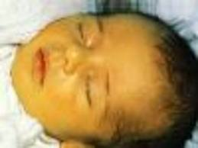

**Picture 4**

**Q4: What is the Danger Sign?**

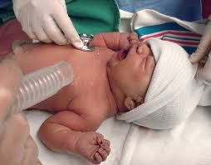



**Picture 5**

**Q5: What is the Danger Sign?**

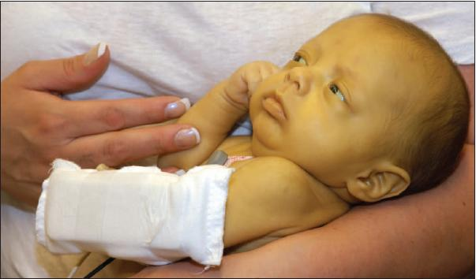

**Candidate Name**

**Answer Sheet for OSCE 7: Danger Signs**

|  |  |  |
| --- | --- | --- |
|  | DANGER SIGNS (Specify the danger sign) |  |
| 1 | Picture 1: |  |
| 2 | Picture 2: |  |
| 3 | Picture 3: |  |
| 4 | Picture 4: |  |
| 5 | Picture 5 |  |
|  | **Total** |  |

**Candidate Name**

**Answer Sheet for OSCE 7: Danger Signs**

|  |  |  |
| --- | --- | --- |
|  | DANGER SIGNS (Specify the danger sign) |  |
| 1 | Picture 1: |  |
| 2 | Picture 2: |  |
| 3 | Picture 3: |  |
| 4 | Picture 4: |  |
| 5 | Picture 5: |  |
|  | **Total** |  |

**Key for Station 7: Danger Signs**

|  |  |  |  |  |  |  |  |  |  |  |  |  |  |  |
| --- | --- | --- | --- | --- | --- | --- | --- | --- | --- | --- | --- | --- | --- | --- |
|  |  |  | **Participants** | | | | | | | | | | | |
| **S. NO** | **Observations** | **Mark** | **1** | **2** | **3** | **4** | **5** | **6** | **7** | **8** | **9** | **10** | **11** | **12** |
| 1 | Pustules | **1.0** |  |  |  |  |  |  |  |  |  |  |  |  |
| 2 | Stiffness and jaundice | **1.0** |  |  |  |  |  |  |  |  |  |  |  |  |
| 3 | Jaundice | **1.0** |  |  |  |  |  |  |  |  |  |  |  |  |
| 4 | Irritability | **1.0** |  |  |  |  |  |  |  |  |  |  |  |  |
| 5 | Lethargy and jaundice | **1.0** |  |  |  |  |  |  |  |  |  |  |  |  |
|  | **TOTAL** | **5.0** |  |  |  |  |  |  |  |  |  |  |  |  |

**Key for Station 7: Danger Signs**

|  |  |  |  |  |  |  |  |  |  |  |  |  |  |  |
| --- | --- | --- | --- | --- | --- | --- | --- | --- | --- | --- | --- | --- | --- | --- |
|  |  |  | **Participants** | | | | | | | | | | | |
| **S. NO** | **Observations** | **Mark** | **13** | **14** | **15** | **16** | **17** | **18** | **19** | **20** | **21** | **22** | **23** | **24** |
| 1 | Pustules | **1.0** |  |  |  |  |  |  |  |  |  |  |  |  |
| 2 | Stiffness | **1.0** |  |  |  |  |  |  |  |  |  |  |  |  |
| 3 | Jaundice | **1.0** |  |  |  |  |  |  |  |  |  |  |  |  |
| 4 | Irritability | **1.0** |  |  |  |  |  |  |  |  |  |  |  |  |
| 5 | Lethargy | **1.0** |  |  |  |  |  |  |  |  |  |  |  |  |
|  | **TOTAL** | **5.0** |  |  |  |  |  |  |  |  |  |  |  |  |

**OSCE Station 8: REST Station**

**OSCE Station 9**

**Differentiation between Still Birth and Live Birth and Checking Gestational Age of Baby**

Tick against true, false or don’t Know for each of the following statements.

|  |  |  |  |
| --- | --- | --- | --- |
| Question | After training | | |
|  | True | False | Don’t Know |
| 1. At birth, if a baby had a good cry, was moving not breathing it is called still birth |  |  |  |
| 1. At birth if a baby had no cry, or breathing but started breathing at 1 minute of birth, was active it is called a live birth |  |  |  |
| 1. At birth if a baby had a cry, was breathing but stopped crying, breathing and moving at 5 minutes after birth it is called still birth |  |  |  |
| 1. At birth and five minutes later If a baby that has just been born does not cry, has no limb movement or is not breathing it is called a live birth |  |  |  |
| 1. At birth if a baby is not breathing, has no cry or no limb movement and the same findings is seen at 5 minutes, it is called still birth |  |  |  |
| 1. Veena comes to the antenatal clinic on January 4. She tells you that her LMP started on 11 October. Her Expected Date of Delivery, if she has regular periods of 28 days cycle, would be June 18 |  |  |  |
| 1. If the LMP started on 11 Oct and the woman comes on January 4th. Her gestational age would be 12weeks +2 days |  |  |  |

**Key for Station 9: Identification of LB versus SB and calculation of EDD and GA**

|  |  |  |  |  |  |  |  |  |  |  |  |  |  |  |
| --- | --- | --- | --- | --- | --- | --- | --- | --- | --- | --- | --- | --- | --- | --- |
|  |  |  | **Participants** | | | | | | | | | | | |
| **S. NO** | **Observations** | **Mark** | **1** | **2** | **3** | **4** | **5** | **6** | **7** | **8** | **9** | **10** | **11** | **12** |
| **1** | **False** | **1** |  |  |  |  |  |  |  |  |  |  |  |  |
| **2** | **True** | **1** |  |  |  |  |  |  |  |  |  |  |  |  |
| **3.** | **False** | **1** |  |  |  |  |  |  |  |  |  |  |  |  |
| **4.** | **False** | **1** |  |  |  |  |  |  |  |  |  |  |  |  |
| **5** | **True** | **1** |  |  |  |  |  |  |  |  |  |  |  |  |
| **6** | **False** | **1** |  |  |  |  |  |  |  |  |  |  |  |  |
| **7.** | **True** | **2** |  |  |  |  |  |  |  |  |  |  |  |  |
|  | **Total** | **8** |  |  |  |  |  |  |  |  |  |  |  |  |

**Key for Station 9: Identification of LB versus SB and calculation of EDD and GA**

|  |  |  |  |  |  |  |  |  |  |  |  |  |  |  |
| --- | --- | --- | --- | --- | --- | --- | --- | --- | --- | --- | --- | --- | --- | --- |
|  |  |  | **Participants** | | | | | | | | | | | |
| **S. NO** | **Observations** | **Mark** | **13** | **14** | **15** | **16** | **17** | **18** | **19** | **20** | **21** | **22** | **23** | **24** |
| **1** | **False** | **1** |  |  |  |  |  |  |  |  |  |  |  |  |
| **2** | **True** | **1** |  |  |  |  |  |  |  |  |  |  |  |  |
| **3.** | **False** | **1** |  |  |  |  |  |  |  |  |  |  |  |  |
| **4.** | **False** | **1** |  |  |  |  |  |  |  |  |  |  |  |  |
| **5** | **True** | **1** |  |  |  |  |  |  |  |  |  |  |  |  |
| **6** | **False** | **1** |  |  |  |  |  |  |  |  |  |  |  |  |
| **7.** | **True** | **2** |  |  |  |  |  |  |  |  |  |  |  |  |
|  | **Total** | **8** |  |  |  |  |  |  |  |  |  |  |  |  |

**OSCE Station 10**

**Addressing Barriers to KMC**

*Read the case given below and then answer the question.*

You are a Community Health Worker and need to implement KMC at the community level.

Write down 2 points you will keep in mind to address factors that can prevent

1. Successful implementation of KMC in the community
2. Acceptance and practice of KMC by the mother

**Name of Candidate:**

**Answer Page for Station 10: Addressing Barriers to KMC**

1. **Two points to address barriers to successful implementation of KMC in the community**
2. **Two points to address barriers to acceptance and practice of KMC by the mother**

**Key for Station 10: Addressing Barriers to KMC**

|  |  |  |  |  |  |  |  |  |  |  |  |  |  |
| --- | --- | --- | --- | --- | --- | --- | --- | --- | --- | --- | --- | --- | --- |
|  | **Observation** | **Marks** | **Participants Serial Number** | | | | | | | | | | |
|  |  |  |  |  |  |  |  |  |  |  |
| 1 | Community (any 2)   * Makes the families in the facility aware of the benefits of KMC * Assist in arranging for an awareness camp about KMC in the community. * Puts posters up for mothers to see about KMC when they go for antenatal checks and remind staff about need to implement KMC   Get a mother who has been successful to talk to other eligible mothers on KMC | 1x2=2 |  |  |  |  |  |  |  |  |  |  |  |
| 2 | Mother and Family (any 2)   * Counsels mother on KMC benefits * Helps mother to position baby first few times * Reinforces how comfortable baby is when in KMC position * Checks with mother about suitable time-structure timing of KMC * Checks with mother about aids she would require for maintaining KMC position * Shows how baby can feed while in KMC position * Checks if there is a support person for her to help her | 1x2=2 |  |  |  |  |  |  |  |  |  |  |  |
|  | Total | 4 |  |  |  |  |  |  |  |  |  |  |  |

**OSCE Station 11**

**Expression of Breast Milk and Feeding by Pallada**

A 34 weeks 1700 grams female baby is born in your hospital by normal delivery.

1. Demonstrate using the breast model how you would express breast milk.
2. Calculate the amount of feed to be given to the baby
3. Show how you feed the baby using a palada.

**Key for Station 11: Expression of Breast Milk and Feeding a Newborn with Pallada**

|  |  |  |  |  |  |  |  |  |  |  |  |  |  |  |  |
| --- | --- | --- | --- | --- | --- | --- | --- | --- | --- | --- | --- | --- | --- | --- | --- |
| **S. NO** | **Observations** | **Marks** | **Participants Serial Number** | | | | | | | | | | | | |
|  |  |  |  |  |  |  |  |  |  |  |  |
| 1 | Collects all articles | **0.5** |  |  |  |  |  |  |  |  |  |  |  |  |
| 2 | Washes hands/ Uses alcohol scrub | **0.5** |  |  |  |  |  |  |  |  |  |  |  |  |
| 3 | Demonstrates on breast model how to express breast milk   * Places a clean container under breast * Massages breast * Places thumb and index finger opposite each other just outside the dark circle around the nipple * Press inwards for milk to flow * Reposition the fingers in clock position and repeat to cover the circumference of breast | **0.5x5=2.5** |  |  |  |  |  |  |  |  |  |  |  |  |
| 4 | Takes a measured amount of feed based on weight of newborn (1700gms – Day 1=80x1.7Kg=136/12=11-12ml every 2 hours | **0.5** |  |  |  |  |  |  |  |  |  |  |  |  |
| 5 | Checks that the baby mannequin is wrapped well, held in sitting semi upright position on the lap or bed | **0.5** |  |  |  |  |  |  |  |  |  |  |  |  |
| 6 | Says the measured amount of feed is poured in the pallada using a syringe (11-12ml) | **1.0** |  |  |  |  |  |  |  |  |  |  |  |  |
| 7 | Begins feeding the Baby   * Holds the pallada so that the end rests on the infants lower lip * Tips the pallada to pour out a small amount of milk into baby’s mouth * Allows baby to suck as it wants * Ensures baby has swallowed milk before giving more * Checks if baby refuses feed | **0.25 x5 = 1.25** |  |  |  |  |  |  |  |  |  |  |  |  |
| 8 | Says she will or acts like she will record amount of feed given | **0.25** |  |  |  |  |  |  |  |  |  |  |  |  |
| 9 | Says she will wash pallada with soap and water, then boiled water and air dry before next use | **1.0** |  |  |  |  |  |  |  |  |  |  |  |  |
|  | **TOTAL** | **8** |  |  |  |  |  |  |  |  |  |  |  |  |

**OSCE Station 12**

**Breast Feeding**

Look at the picture of a new-born breast feeding. Then, read the points given under position and attachment in the ANSWER SHEET.

**Write against each POINT if YES OR NO**



**Candidate Name**

**Answer Sheet for OSCE 12: Position and attachment for breast feeding**

|  |  |  |  |  |
| --- | --- | --- | --- | --- |
|  |  | YES | NO | Mark |
|  | **Position (Mention if Yes or NO)** |  |  |  |
| 1 | Baby’s head and body in straight line |  |  |  |
| 2 | Baby’s head and body facing mother |  |  |  |
| 3 | Baby’s body close to mother |  |  |  |
| 4 | Baby’s whole-body well supported |  |  |  |
|  |  |  |  |  |
|  | **Attachment (Mention if Yes or NO)** |  |  |  |
| 5 | Mouth wide open |  |  |  |
| 6 | Chin touching breast |  |  |  |
| 7 | More areola seen above than below |  |  |  |
| 8 | Lower lip everted (turned outward) |  |  |  |
|  |  |  |  |  |
| 9 | Is the baby correctly positioned? |  |  |  |
| 10 | Is the baby attached correctly? |  |  |  |

**Key for Station 12: Position and Attachment for Breast Feeding**

|  |  |  |  |  |  |  |  |  |  |  |  |  |  |  |
| --- | --- | --- | --- | --- | --- | --- | --- | --- | --- | --- | --- | --- | --- | --- |
|  |  |  | **Participants** | | | | | | | | | | | |
| **S.**  **NO** | **Observations** | **Marks** |  |  |  |  |  |  |  |  |  |  |  |  |
|  | **POSITION** |  |  |  |  |  |  |  |  |  |  |  |  |  |
|  | Baby’s head and body NOT in straight line | **0.25** |  |  |  |  |  |  |  |  |  |  |  |  |
|  | Baby’s head and body NOT facing mother | **0.25** |  |  |  |  |  |  |  |  |  |  |  |  |
|  | Baby’s body NOT close to mother | **0.25** |  |  |  |  |  |  |  |  |  |  |  |  |
|  | Baby’s whole body NOT well supported | **0.25** |  |  |  |  |  |  |  |  |  |  |  |  |
|  | **ATTACHMENT** |  |  |  |  |  |  |  |  |  |  |  |  |  |
|  | Mouth NOT wide open | **0.5** |  |  |  |  |  |  |  |  |  |  |  |  |
|  | Chin NOT touching breast | **0.5** |  |  |  |  |  |  |  |  |  |  |  |  |
|  | Areola NOT covered completely by mouth and more NOT seen above | **0.5** |  |  |  |  |  |  |  |  |  |  |  |  |
|  | Lower lip NOT everted/turned outward | **0.5** |  |  |  |  |  |  |  |  |  |  |  |  |
|  |  |  |  |  |  |  |  |  |  |  |  |  |  |  |
|  | Baby NOT positioned well | **1.0** |  |  |  |  |  |  |  |  |  |  |  |  |
|  | Baby NOT attached well | **1.0** |  |  |  |  |  |  |  |  |  |  |  |  |
|  | **TOTAL** | **5** |  |  |  |  |  |  |  |  |  |  |  |  |

**OSCE Station 13 – REST**