**Rapid Assessment of Competencies for Care of LBW including KMC for Nurse Mentors**

**Assessment Plan**

|  |  |  |  |
| --- | --- | --- | --- |
| **Station** | **Details** | **Marks** | **Observed /Not Observed** |
|  | Mentoring a nurse, checking weight, checking & swaddling a NB | 5 | **Observed** |
|  | Radiant warmer; identification of temperature-case based and picture | 5 | Unobserved |
|  | Counselling a mother/ family member on KMC | 8 | **Observed** |
|  | REST |  |  |
|  | Counselling a mother/ care taker on prevention of infection at home | 8 | **Observed** |
|  | Feeding: Attachment/ position (picture) | 4 | Unobserved |
|  | KMC Position | 7 | Observed |
|  | Danger signs (picture/ video and case based) | 3 | Unobserved |
|  | REST |  |  |
|  | Checking Temperature and GRBS | 8 | **Observed** |
|  | Ways to address barriers of KMC | 4 | Unobserved |
|  | Feeding a newborn by pallada and expression of breast milk using the breast model | 8 | **Observed** |
|  | REST |  |  |

**General instructions to be given by one facilitator to all the participants**

* Each one will go through 10 stations and 3 rest stations.
* There are 6 observed and 4 unobserved stations for this rapid exercise.
* In the observed stations, you will be expected to perform some activities. Complete the task within the given time.
* In the unobserved stations, you will be asked to write some information on the answer sheet. Write your name and your participant number on the answer sheet, too. Once you completed it, fold the answer sheet and place it in the box provided.
* The duration of each station will be 4 minutes.
* None of the facilitators will make any comments, nor give assistance.
* Three stations have volunteers to help one in completing the station.
* When a bell rings, everybody goes to the assigned station, based on participant number.
* In the beginning, do not face the station.
* When the bell rings again, each participant can turn around and read the participant instructions. Complete the tasks given.
* If you complete the task before the given time, sit down in the chair and wait.
* When the bell rings again, you must move to the next station.
* All participants will go through all the stations.
* The rapid exercise will take approximately 50 minutes.
* No one will be allowed to leave the room during the rapid exercise.

**OSCE Overall Evaluation**

*: Observed Stations = 38 Unobserved Stations =12

|  |  |  |  |  |  |  |  |  |  |  |  |  |  |
| --- | --- | --- | --- | --- | --- | --- | --- | --- | --- | --- | --- | --- | --- |
| Candidates | **Stations** | | | | | | | | | | | | **Grand**  **Total**  **(60)** |
| **1\*** | **2** | **3\*** | **4** | **5\*** | **6** | **7** | **8** | **9\*** | **10** | **11\*** | **12** |
| **MARKS** | | | | | | | | | | | |
| **(5)** | **(5)** | **(8)** | **(R)** | **(8)** | **(4)** | **(7)** | **(3)** | **(R)** | **(8)** | **(4)** | **(8)** |
| 1. |  |  |  |  |  |  |  |  |  |  |  |  |  |
| 2 |  |  |  |  |  |  |  |  |  |  |  |  |  |
| 3 |  |  |  |  |  |  |  |  |  |  |  |  |  |
| 4 |  |  |  |  |  |  |  |  |  |  |  |  |  |
| 5 |  |  |  |  |  |  |  |  |  |  |  |  |  |
| 6 |  |  |  |  |  |  |  |  |  |  |  |  |  |
| 7 |  |  |  |  |  |  |  |  |  |  |  |  |  |
| 8 |  |  |  |  |  |  |  |  |  |  |  |  |  |
| 9 |  |  |  |  |  |  |  |  |  |  |  |  |  |
| 10 |  |  |  |  |  |  |  |  |  |  |  |  |  |
| 11 |  |  |  |  |  |  |  |  |  |  |  |  |  |
| 12 |  |  |  |  |  |  |  |  |  |  |  |  |  |

**Requirements for Each Rapid Assessment Station**

|  |  |  |
| --- | --- | --- |
| **General requirements**   * Juice for volunteers and faculty * Snacks * Cellotape | * Instructions for each station * Files to place the key for each station – 10 * Bell, stopwatch | |
| **Station 1: Mentoring a Nurse Checking the Weight and Swaddling a new-born**   * Mannequin - * One baby sheet/ towel * Cotton swab with spirit * Weighting machine * Kidney tray * Paper sheet to record weight of the mannequin * Key for scoring candidate * Table * Chairs (2) * Volunteer /observer to act as a nurse | | **Station 7: KMC Position**   * Baby-Preminatalie * Dupatta / KMC bag * Chair (1) * Table (1) - optional * Volunteer / observer to act as a mother |
| **Station 2:Radiant Warmer and Identification of Temperature Case-based**   * Table * Case scenario * Answer sheet for each candidate to fill in * Key for scoring candidate * Chair -1 | | **Station 8: Danger Signs of a Newborn**   * Video of danger signs or laminated pictures of danger signs  1. Cyanosis or blue baby 2. Skin pustules 3. Stiff baby 4. Jaundice (both) 5. Case scenario  * Answer sheet for each candidate * Key for scoring candidate * Table -1 * Chair -1 |
| **Station 3: Counselling a Mother / Care Taker on KMC**   * Baby-Preminatalie * Dupatta / KMC bag * Chair (1) * Table (1) Optional * Volunteer / Observer to act as a mother | | **Station 9: REST**   * Chair * Table |
| **Station 4:REST**   * Chair (1) * Table (1) | | **Station 10: Checking Temperature and GRBS of a New-born**   * Mannequin * Thermometer * Spirit swab * Kidney tray * Container to keep thermometer in after completing the procedure * Alcohol rub solution * Chair * Table/couch * GRBS machine * Lancet * Towel to wrap baby * Case sheet * Key for scoring candidate |
| **Station 5: Counselling a Mother on Prevention of Infection at Home**   * Key for scoring candidate * Table-1 * Chair-2 * Volunteer / observer to act a mother | | **Station 11: Ways to Address Barriers to KMC**   * Case Scenario * Chair - 1 * Table -1 * Key for scoring candidate |
| **Station 6: Breast feeding –Position and Attachment**   * Laminated picture of position and attachment * Answer sheet for participants * Scoring key | | **Station 12.Feeding a Newborn by Pallada and Expression of Breast Milk**   * Breast milk model * Pallada * Mannequin * Container to store breast milk * Alcohol hand scrub * Key for scoring candidate * Table-1 * Chair-1 |

**OSCE Station 1:**

**Mentoring a Staff Checking Weight and Swaddling a Newborn**

1. Watch the nurse demonstrating checking weight and swaddling of the newborn mannequin.
2. Mentor the staff nurse on the competency checking weight and swaddling of a newborn.

**Key for Station 1: Mentoring a Nurse Checking Weight and Swaddling a Newborn (5)**

|  |  |  |  |  |  |  |  |  |  |  |  |  |  |  |
| --- | --- | --- | --- | --- | --- | --- | --- | --- | --- | --- | --- | --- | --- | --- |
|  |  |  | **Participants** | | | | | | | | | | | |
| S. NO | Observations | **Mark** | **1** | **2** | **3** | **4** | **5** | **6** | **7** | **8** | **9** | **10** |  |  |
|  | Observes staff nurse without interrupting her when she is checking weight and swaddling the baby mannequin. | **0.25** |  |  |  |  |  |  |  |  |  |  |  |  |
| 2 | Introduces self, starts with telling nurse the correct things she did. | **0.25** |  |  |  |  |  |  |  |  |  |  |  |  |
| 3 | Identifies the mistakes (3). | **0.25x3=0.75** |  |  |  |  |  |  |  |  |  |  |  |  |
|  | 1.Do not clean the tray. |  |  |  |  |  |  |  |  |  |  |  |  |  |
|  | 2.Forget to adjust the knop for setting the weight scale to zero. |  |  |  |  |  |  |  |  |  |  |  |  |  |
|  | 3.Do not place the mannequin/baby in the centre of the tray / pan. |  |  |  |  |  |  |  |  |  |  |  |  |  |
| 4 | Correctly demonstrates all the steps (8). | **0.25x8=2.0** |  |  |  |  |  |  |  |  |  |  |  |  |
|  | 1.Cleans the tray/pan of weighing scale with spirit or soap and water soaked cotton swab or gauze. |  |  |  |  |  |  |  |  |  |  |  |  |  |
|  | 2.Places cloth over the tray / pan of weighing scale in centre. |  |  |  |  |  |  |  |  |  |  |  |  |  |
|  | **3**.Sets the weighing scale to zero.   * Adjusts knob so that reading is zero in beam scale. * Allows the digital scale to adjust to zero automatically or uses the knob. |  |  |  |  |  |  |  |  |  |  |  |  |  |
|  | **4.**Uses alcohol hand rub/washes hand thoroughly. |  |  |  |  |  |  |  |  |  |  |  |  |  |
|  | **5**.Places the mannequin/baby in the centre of the tray / pan. |  |  |  |  |  |  |  |  |  |  |  |  |  |
|  | **6**. Notes and records the weight accurately.   * Waits till the needle is more or less stable, notes the reading on the scale to the nearest 0.01kg * Waits till the number displayed is more or less stable, freezes the reading. |  |  |  |  |  |  |  |  |  |  |  |  |  |
|  | 7.Classifies the mannequin / baby – LBW. |  |  |  |  |  |  |  |  |  |  |  |  |  |
|  | **8**. Puts clothes for mannequin / baby: cap, napkin, socks, mittens and swaddles the baby well. |  |  |  |  |  |  |  |  |  |  |  |  |  |
| 5 | Asks if nurse has understood. | **0.25** |  |  |  |  |  |  |  |  |  |  |  |  |
| 6 | Asks her to demonstrate. | **0.5** |  |  |  |  |  |  |  |  |  |  |  |  |
| 7 | Gives positive reinforcement. Is gentle, non-threatening, non-judgmental. | **0.5** |  |  |  |  |  |  |  |  |  |  |  |  |
| 9 | Explains why it is important to do the procedure correctly. | **0.5** |  |  |  |  |  |  |  |  |  |  |  |  |
|  | TOTAL | **5** |  |  |  |  |  |  |  |  |  |  |  |  |

**OSCE Station 2**

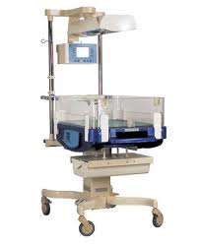

**Radiant Warmer**

*You have 10 questions on the radiant warmer. Circle either “True” or “false” for all 6 questions in the answer sheet.*

*Please write your Name and Serial number in the answer sheet.*

**Candidate Name:...............................**

**Answer Sheet for Station 2: Radiant Warmer**

1. All babies must be kept under a radiant warmer soon after birth. ***True / False***
2. The servo mode temperature is set at 380C. ***True / False***
3. The manual mode is used when a baby is first placed under radiant warmer. ***True / False***
4. A baby under radiant warmer loses more fluids. ***True / False***
5. All babies, who need resuscitation must be placed under a radiant warmer. ***True / False***
6. If a baby is overheated under radiant warmer, then the skin will be flushed (red), axilla temperature will be normal, the body and feet/hands will be cold to touch**.** ***True / False***
7. A low birth weight baby, who is 1800gms and stable, would need to be placed under a radiant warmer ***True / False***
8. If an incubator is not available for transport of a LBW to a higher level hospital, it is better to swaddle the baby well and transport it, than to keep the baby in skin to skin with the mother. ***True / False***
9. A warmer is set at 36.50C. The baby has a temperature of 380C. The heater output is zero. The nurse should put off the radiant warmer. ***True / False***
10. Connect the radiant warmer unit to mains 20 minutes before anticipated arrival of newborn. Switch it on, select manual mode and the heater output to 80% for prewarming.  ***True / False***

**Key for Station 2: Radiant Warmer and Identification of Temperature Case Based – True or False**

|  |  |  |  |  |  |  |  |  |  |  |  |  |  |  |
| --- | --- | --- | --- | --- | --- | --- | --- | --- | --- | --- | --- | --- | --- | --- |
|  |  |  | **Participants** | | | | | | | | | | | |
| **S. NO** | **Observations** | **Marks** |  |  |  |  |  |  |  |  |  |  |  |  |
| 1 | Answer – False | **0.5** |  |  |  |  |  |  |  |  |  |  |  |  |
| 2 | Answer – False | **0.5** |  |  |  |  |  |  |  |  |  |  |  |  |
| 3 | Answer – True | **0.5** |  |  |  |  |  |  |  |  |  |  |  |  |
| 4 | Answer – True | **0.5** |  |  |  |  |  |  |  |  |  |  |  |  |
| 5 | Answer – True | **0.5** |  |  |  |  |  |  |  |  |  |  |  |  |
| 6 | Answer – False | **0.5** |  |  |  |  |  |  |  |  |  |  |  |  |
| 7 | Answer – True | **0.5** |  |  |  |  |  |  |  |  |  |  |  |  |
| 8 | Answer – False | **0.5** |  |  |  |  |  |  |  |  |  |  |  |  |
| 9. | Answer – True | **0.5** |  |  |  |  |  |  |  |  |  |  |  |  |
| 10. | Answer – False | **0.5** |  |  |  |  |  |  |  |  |  |  |  |  |
|  | TOTAL | **5.0** |  |  |  |  |  |  |  |  |  |  |  |  |

**OSCE Station 3**

**Counselling a Mother / Care Taker on KMC**

Ms Asha has a 1800gm baby that is stable. You have to counsel her to start KMC.

Demonstrate how you would counsel her on providing KMC.

**Key for Station 3: Counselling a Mother / Care Taker on KMC**

|  |  |  |  |  |  |  |  |  |  |  |  |  |  |  |
| --- | --- | --- | --- | --- | --- | --- | --- | --- | --- | --- | --- | --- | --- | --- |
|  |  |  | **Participants Serial No.** | | | | | | | | | | | |
| **S. NO** | **Observations** | **Marks** |  |  |  |  |  |  |  |  |  |  |  |  |
|  | Introduces self and calls her by name. | **0.5** |  |  |  |  |  |  |  |  |  |  |  |  |
|  | Explains the need for KMC, benefit. | **0.5x4=**  **2.0** |  |  |  |  |  |  |  |  |  |  |  |  |
|  | Demonstrates KMC for the mother voluntarily after checking what she is comfortable to do. | **0.5x2=**  **1.0** |  |  |  |  |  |  |  |  |  |  |  |  |
|  | Asks the mother what would help her to give KMC. | **1.0** |  |  |  |  |  |  |  |  |  |  |  |  |
|  | Asks the mother what would prevent her from giving KMC. | **0.5x2=1** |  |  |  |  |  |  |  |  |  |  |  |  |
|  | Mother demonstrates how to position newborn for KMC. | **0.5** |  |  |  |  |  |  |  |  |  |  |  |  |
|  | Has a good rapport. | **1.0** |  |  |  |  |  |  |  |  |  |  |  |  |
|  | Recollects the information shared. | **1.0** |  |  |  |  |  |  |  |  |  |  |  |  |
|  | TOTAL | **8** |  |  |  |  |  |  |  |  |  |  |  |  |

**OSCE Station 4 – REST**

**OSCE Station 5**

**Counselling of a Mother KMC maintenance – barriers; danger signs and follow-up**

A 34 weeks 1900 grams female baby is born in your facility by normal delivery.

The mother is confident in giving KMC and the baby is stable and ready for discharge. Counsel the mother on KMC maintenance – barriers; danger signs and follow-up.

**Key for Station 5: Counselling a Mother on Prevention of Infection at Home**

|  |  |  |  |  |  |  |  |  |  |  |  |  |  |  |
| --- | --- | --- | --- | --- | --- | --- | --- | --- | --- | --- | --- | --- | --- | --- |
|  |  |  | **Participants** |  |  |  |  |  |  |  |  |  |  |  |
| **S. NO** | **Observations** | **Marks** |  |  |  |  |  |  |  |  |  |  |  |  |
|  | Introduces self and greets parents. | **0.5** |  |  |  |  |  |  |  |  |  |  |  |  |
|  | Checks with the mother how infections can be prevented. | **0.5** |  |  |  |  |  |  |  |  |  |  |  |  |
|  | Reinforces any correct information. | **0.5** |  |  |  |  |  |  |  |  |  |  |  |  |
|  | Explains that the baby is stable and is ready for discharge. | **0.5** |  |  |  |  |  |  |  |  |  |  |  |  |
|  | Explains that the baby is prone to infections since he/she is preterm. | **0.5** |  |  |  |  |  |  |  |  |  |  |  |  |
|  | Discusses about exclusive breast feeding. | **0.5** |  |  |  |  |  |  |  |  |  |  |  |  |
|  | Discusses about continuation of KMC and keeping the baby warm. | **1.0** |  |  |  |  |  |  |  |  |  |  |  |  |
|  | Reinforces to avoid applying anything on the umbilical stump. | **0.5** |  |  |  |  |  |  |  |  |  |  |  |  |
|  | Reinforces about avoiding giving any oils or anything else orally to the newborn. | **0.5** |  |  |  |  |  |  |  |  |  |  |  |  |
|  | Body posture/tone of voice/eye to eye contact/asks for any doubts and clarifies. | **0.5 x4 = 2.0** |  |  |  |  |  |  |  |  |  |  |  |  |
|  | Reinforces information by asking mother or she summarises main points. | **1.0** |  |  |  |  |  |  |  |  |  |  |  |  |
|  | **TOTAL** | **8.0** |  |  |  |  |  |  |  |  |  |  |  |  |

**OSCE Station 6**

**Breast Feeding**

Look at the picture of a new-born breast feeding. Then, read the points given under position and attachment in the ANSWER SHEET.

**Write against each POINT if YES OR NO**



**Candidate Name**

**Answer Sheet for OSCE 6: Position and attachment for breast feeding**

|  |  |  |  |  |
| --- | --- | --- | --- | --- |
|  |  | YES | NO | Mark |
|  | **Position (Mention if Yes or NO)** |  |  |  |
| 1 | Baby’s head and body in straight line. |  |  |  |
| 2 | Baby’s head and body facing mother. |  |  |  |
| 3 | Baby’s body close to mother. |  |  |  |
| 4 | Baby’s whole body well supported. |  |  |  |
|  |  |  |  |  |
|  | **Attachment (Mention if Yes or NO)** |  |  |  |
| 5 | Mouth wide open |  |  |  |
| 6 | Chin touching breast |  |  |  |
| 7 | More areola seen above than below |  |  |  |
| 8 | Lower lip everted (turned outward) |  |  |  |
|  |  |  |  |  |
| 9 | Is the baby correctly positioned? |  |  |  |
| 10 | Is the baby attached correctly? |  |  |  |

**Key for Station 6: Position and Attachment for Breast Feeding**

|  |  |  |  |  |  |  |  |  |  |  |  |  |  |  |
| --- | --- | --- | --- | --- | --- | --- | --- | --- | --- | --- | --- | --- | --- | --- |
|  |  |  | **Participants** | | | | | | | | | | | |
| **S.**  **NO** | **Observations** | **Marks** |  |  |  |  |  |  |  |  |  |  |  |  | |
|  | **POSITION** |  |  |  |  |  |  |  |  |  |  |  |  |  | |
|  | Baby’s head and body NOT in straight line. | **0.25** |  |  |  |  |  |  |  |  |  |  |  |  | |
|  | Baby’s head and body NOT facing mother. | **0.25** |  |  |  |  |  |  |  |  |  |  |  |  | |
|  | Baby’s body NOT close to mother. | **0.25** |  |  |  |  |  |  |  |  |  |  |  |  | |
|  | Baby’s whole body NOT well supported. | **0.25** |  |  |  |  |  |  |  |  |  |  |  |  | |
|  | **ATTACHMENT** |  |  |  |  |  |  |  |  |  |  |  |  |  | |
|  | Mouth NOT wide open | **0.25** |  |  |  |  |  |  |  |  |  |  |  |  | |
|  | Chin NOT touching breast | **0.25** |  |  |  |  |  |  |  |  |  |  |  |  | |
|  | More areola NOT seen above than below | **0.25** |  |  |  |  |  |  |  |  |  |  |  |  | |
|  | Lower lip NOT everted | **0.25** |  |  |  |  |  |  |  |  |  |  |  |  | |
|  |  |  |  |  |  |  |  |  |  |  |  |  |  |  | |
|  | Baby NOT attached and positioned well. | **1.0** |  |  |  |  |  |  |  |  |  |  |  |  | |
|  | Baby NOT positioned well. | **1.0** |  |  |  |  |  |  |  |  |  |  |  |  | |
|  |  | **4** |  |  |  |  |  |  |  |  |  |  |  |  | |

**OSCE Station 7**

**KMC**

Help the volunteer to position for KMC using the Preminatalie newborn baby.

**Key for Station 7:KMC Position**

|  |  |  |  |  |  |  |  |  |  |  |  |  |  |
| --- | --- | --- | --- | --- | --- | --- | --- | --- | --- | --- | --- | --- | --- |
|  |  |  | **Participants Serial No.** | | | | | | | | | | |
| **S. NO** | **Observations** | **Marks** |  |  |  |  |  |  |  |  |  |  |  |
| 1 | Describes the various aspects of KMC to the mother.   * Position, * Feeding options, * Care in the institution and at home, * What she can do for the baby when baby is in KMC position and what she should avoid. * Explain the advantages and the implications of such care for her and her baby with the reasons for recommendations. | **1.5** |  |  |  |  |  |  |  |  |  |  |  |
| 2 | Collects the needed supplies  For mother:   * Front open dress, KMC Bag or binder or Shawl, KMC Chair if available   For baby:   * Cap, Socks, disposal diaper | **0.5** |  |  |  |  |  |  |  |  |  |  |  |
| 3 | Instructs the mother volunteer on the need to wear front open dress. | **0.5** |  |  |  |  |  |  |  |  |  |  |  |
| 4 | Encourages the mother to sit comfortably on the chair, preferably KMC chair if available. | **0.5** |  |  |  |  |  |  |  |  |  |  |  |
| 5 | Puts cap, socks, and diaper for the baby and places the baby in the KMC bag if available. | **0.5** |  |  |  |  |  |  |  |  |  |  |  |
| 6 | Positions the baby for KMC:   * Places the baby between mother’s breasts in an upright position. | **1** |  |  |  |  |  |  |  |  |  |  |  |
|  | * Ensures the head is turned to one side and in a slightly extended position. | **1** |  |  |  |  |  |  |  |  |  |  |  |
|  | * Ensures the hips are flexed and abducted in a “frog” position; the arms are also flexed. | **1** |  |  |  |  |  |  |  |  |  |  |  |
|  | * Supports the infant from the bottom with a sling/binder and palm. | **0.5** |  |  |  |  |  |  |  |  |  |  |  |
|  | Total | **7** |  |  |  |  |  |  |  |  |  |  |  |

**OSCE Station 8**

**Name the Danger Sign**

There are 4 different pictures. Each picture shows a new-born presenting with a danger sign (Picture No 1-4).

* From the picture, identify the danger sign. Write the answer in the blank space on the sheet given against each question number (1-4).
* Read question 5 and answer the question (Qs 5)

**Picture 1**

**Q1: What is the Danger Sign?**

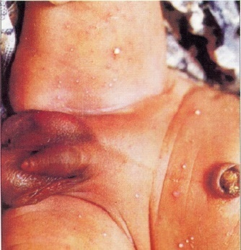

**Picture 2**

**Q2: What is the Danger Sign?**

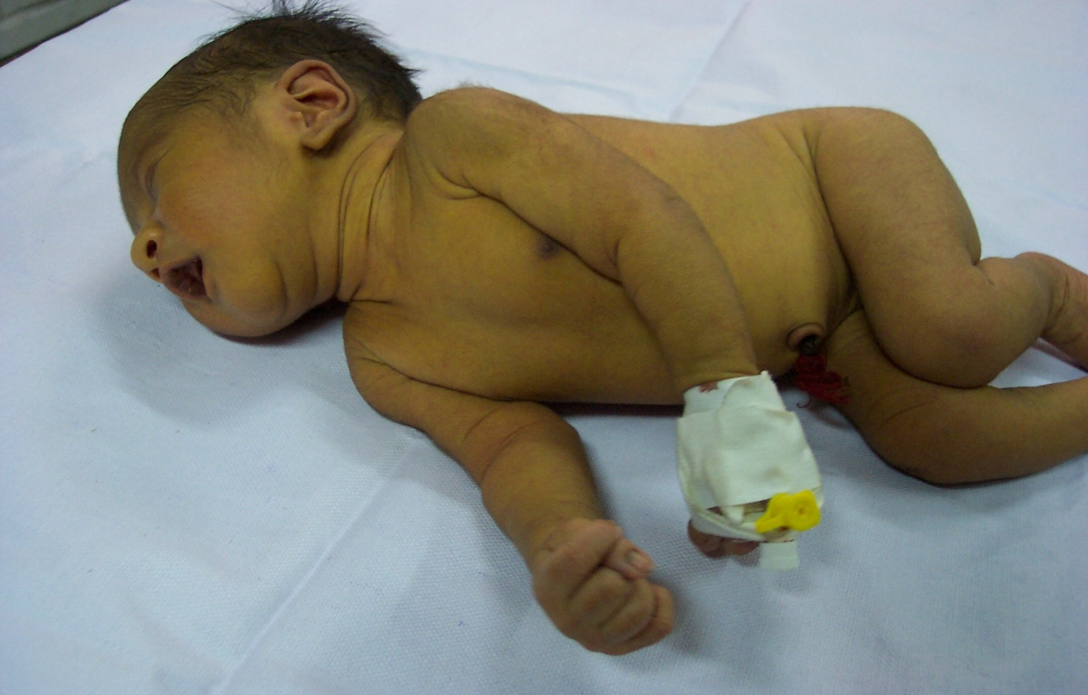

**Picture 3**

**Q3: What is the Danger Sign?**

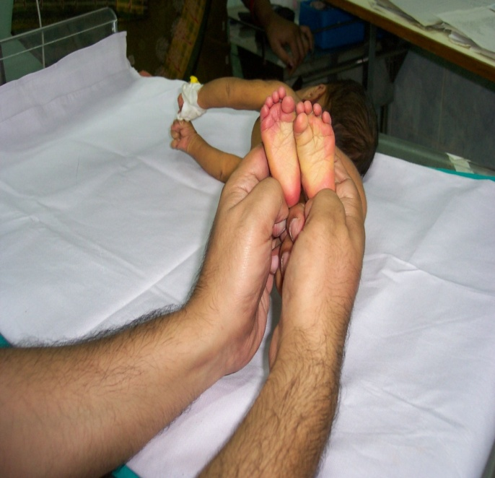

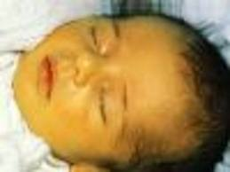

**Picture 4**

**Q4: What is the Danger Sign?**

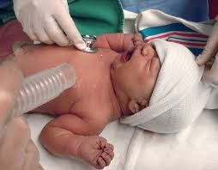

Q5. A term new-born weighing 2000gms is not feeding on day 2.

On examination, the baby is lethargic, RR is 72/minute and temperature is 350C.

*Write all the danger signs of this case in the space provided in the answer sheet.*

**Candidate Name**

**Answer Sheet for OSCE 8: Danger Signs**

|  |  |  |
| --- | --- | --- |
|  | DANGER SIGNS (Specify the danger sign) |  |
| 1 | Picture 1: |  |
| 2 | Picture 2: |  |
| 3 | Picture 3: |  |
| 4 | Picture 4: |  |
| 5 | Case Scenario: |  |
|  | **Total** |  |

**Key for Station 8:Danger Signs**

|  |  |  |  |  |  |  |  |  |  |  |  |  |  |  |
| --- | --- | --- | --- | --- | --- | --- | --- | --- | --- | --- | --- | --- | --- | --- |
|  |  |  | **Participants** | | | | | | | | | | | |
| **S. NO** | **Observations** | **Mark** | **1** | **2** | **3** | **4** | **5** | **6** | **7** | **8** | **9** | **10** |  |  |
| 1 | Pustules | **0.5** |  |  |  |  |  |  |  |  |  |  |  |  |
| 2 | Stiffness | **0.5** |  |  |  |  |  |  |  |  |  |  |  |  |
| 3 | Jaundice | **0.5** |  |  |  |  |  |  |  |  |  |  |  |  |
| 4 | Irritability | **0.5** |  |  |  |  |  |  |  |  |  |  |  |  |
| 5 | Writes all danger signs from case scenario   * Not feeding * Lethargic * RR 72/minute * Temperature 360C | **0.25x4** |  |  |  |  |  |  |  |  |  |  |  |  |
|  | **TOTAL** | **4** |  |  |  |  |  |  |  |  |  |  |  |  |

**OSCE Station 9-Rest**

**OSCE Station 10**

**Checking Temperature and GRBS of a Newborn**

Demonstrate how you will check temperature and the GRBS for a newborn.

**Key for Station 10: Checking Temperature and GRBS of a New-born**

|  |  |  |  |  |  |  |  |  |  |  |  |  |  |  |
| --- | --- | --- | --- | --- | --- | --- | --- | --- | --- | --- | --- | --- | --- | --- |
|  |  |  | **Participants** | | | | | | | | | | | |
| **S. NO** | **Records the following on the case sheet** | **Marks** |  |  |  |  |  |  |  |  |  |  |  |  |
| 1 | Collects the articles/supplies-thermometer, cotton swab with spirit, dry cotton balls | **0.25** |  |  |  |  |  |  |  |  |  |  |  |  |
| 2 | Wipes thermometer with dry cotton from bulb to stem | **0.25** |  |  |  |  |  |  |  |  |  |  |  |  |
| 3 | Checks the reading of thermometer, shakes it so that mercury level is below the lowest temperature recording | **0.5** |  |  |  |  |  |  |  |  |  |  |  |  |
| 4 | Places the thermometer horizontal to body of the baby mannequin in arm pit, so that bulb is in close skin contact. Holds the arm close to the body | **0.5** |  |  |  |  |  |  |  |  |  |  |  |  |
| 5 | Keeps the thermometer in place for 3 minutes. Observes heart rate and respiration | **0.5** |  |  |  |  |  |  |  |  |  |  |  |  |
| 6 | Removes thermometer, wipes the thermometer with spirit cotton swab from stem to bulb and then with dry cotton swab. | **0.5** |  |  |  |  |  |  |  |  |  |  |  |  |
| 7 | Checks the reading of thermometer holding it at eye level and rotating it so that the mercury level is clearly visible | **0.5** |  |  |  |  |  |  |  |  |  |  |  |  |
| 8 | Informs the observer about the temperature | **1.0** |  |  |  |  |  |  |  |  |  |  |  |  |
| 9 | Cleans hands | **0.5** |  |  |  |  |  |  |  |  |  |  |  |  |
| 10 | Wears gloves | **0.5** |  |  |  |  |  |  |  |  |  |  |  |  |
| 11 | Cleans site, waits for it to dry, does not squeeze the site | **0.5** |  |  |  |  |  |  |  |  |  |  |  |  |
| 12 | Marks site for doing heal prick | **1.0** |  |  |  |  |  |  |  |  |  |  |  |  |
| 13 | Shows on the glucometer how to read glucose level | **0.5** |  |  |  |  |  |  |  |  |  |  |  |  |
| 14 | Gives the reading | **1.0** |  |  |  |  |  |  |  |  |  |  |  |  |
|  | **TOTAL** | **8** |  |  |  |  |  |  |  |  |  |  |  |  |

**OSCE Station 11**

**Addressing Barriers to KMC**

*Read the case given below and then answer the question.*

You are a nurse mentor in a Taluk level hospital which is going to be a KMC implementation facility.

Write down 2 points you will keep in mind to address factors that can prevent

1. Successful implementation of KMC in the Facility
2. Acceptance and practice of KMC by the mother

**Name of Candidate:**

**Answer Page for Station 11: Addressing Barriers to KMC**

1. **Two points to address barriers to successful implementation of KMC in the facility**
2. **Two points to address barriers to acceptance and practice of KMC by the mother**

**Key for Station 11: Addressing Barriers to KMC**

|  |  |  |  |  |  |  |  |  |  |  |  |  |  |  |  |
| --- | --- | --- | --- | --- | --- | --- | --- | --- | --- | --- | --- | --- | --- | --- | --- |
| **S. NO** | **Observations** | **Marks** | **Participants Serial Number** | | | | | | | | | | | | |
|  |  |  |  |  |  |  |  |  |  |  |  |
| 1 | Health facility (any 2)   * Makes the staff in the facility aware of the benefits of KMC * Assists staff in arranging a unit for KMC * Puts posters up for mothers to learn about KMC and reminds staff about need to implement KMC * Reinforces best practices by staff on KMC | 1x2=2 |  |  |  |  |  |  |  |  |  |  |  |  |
| 2 | Mother and Family (any 2)   * Counsels mother on KMC benefits * Helps mother to position baby first few times * Reinforces how comfortable baby is when in KMC position * Checks with mother about suitable timing of KMC * Checks with mother about aids she would require for maintaining KMC position * Shows how baby can feed, while in KMC position * Checks if there is a support person for her to help her | 1x2=2 |  |  |  |  |  |  |  |  |  |  |  |  |
|  | Total | 4 |  |  |  |  |  |  |  |  |  |  |  |  |

**OSCE Station 12**

**Expression of Breast Milk and Feeding by Pallada**

A 34 weeks 1700 grams female baby is born in your hospital by normal delivery.

1. Demonstrate using the breast model how you would express breast milk.
2. Calculate the amount of feed to be given to the baby
3. Show how you feed the baby using a palada.

**Key for Station 12: Expression of Breast Milk andFeeding a Newborn by Pallada**

|  |  |  |  |  |  |  |  |  |  |  |  |  |  |  |  |
| --- | --- | --- | --- | --- | --- | --- | --- | --- | --- | --- | --- | --- | --- | --- | --- |
| **S. NO** | **Observations** | **Marks** | **Participants Serial Number** | | | | | | | | | | | | |
|  |  |  |  |  |  |  |  |  |  |  |  |
| 1 | Collects all articles | **0.5** |  |  |  |  |  |  |  |  |  |  |  |  |
| 2 | Washes hands/ Uses alcohol scrub | **0.5** |  |  |  |  |  |  |  |  |  |  |  |  |
| 3 | Demonstrates on breast model how to express breast milk   * Places a clean container under breast * Massages breast * Places thumb and index finger opposite each other just outside the dark circle around the nipple * Presses inwards for milk to flow * Repositions the fingers in clock position and repeats to cover the circumference of breast | **0.5x5=2.5** |  |  |  |  |  |  |  |  |  |  |  |  |
| 4 | Takes a measured amount of feed based on weight of newborn (1700gms – Day 1=80x1.7Kg=136/12=13ml every 2 hours | **0.5** |  |  |  |  |  |  |  |  |  |  |  |  |
| 5 | Checks that the baby mannequin is wrapped well, held in sitting semi upright position on the lap or bed | **0.5** |  |  |  |  |  |  |  |  |  |  |  |  |
| 6 | Says the measured amount of feed is poured in the palada (13ml) | **1.0** |  |  |  |  |  |  |  |  |  |  |  |  |
| 7 | Begins feeding the Baby   * Holds the palada so that the end rests on the infants lower lip * Tips the palada to pour out a small amount of milk into baby’s mouth * Allows baby to suck as it wants * Ensures baby has swallowed milk before giving more * Checks if baby refuses feed | **0.25 x5 = 1.25** |  |  |  |  |  |  |  |  |  |  |  |  |
| 8 | Says she will or acts like she will record amount of feed given | **0.25** |  |  |  |  |  |  |  |  |  |  |  |  |
| 9 | Says she will wash palada with soap and water, then boiled water and air dry before next use | **1.0** |  |  |  |  |  |  |  |  |  |  |  |  |
|  | **TOTAL** | **8** |  |  |  |  |  |  |  |  |  |  |  |  |