**Handout**

**Guidelines for Modes of Providing Fluids and Feeding for Newborns**

|  |  |  |  |
| --- | --- | --- | --- |
| Age | Classification of newborns | | |
| Birth weight (gm) | Less than 1200 | 1200-1800 | More than 1800 |
| Gestation (weeks) | Less than 30 | 30-34 | More than 34 |
| Initial | IV fluids. Try tube feeds of expressed breast milk (EBM) if not sick | Tube feeds – EBM | Direct Breast Feeding (DBF).  If poor feeding, give pallada or cup feeds |
| After 1-3 days | Tube feeds - EBM | Pallada/cup feeds - EBM | DBF |
| Later (1-3 weeks) | Pallada/cup - EBM | DBF | DBF |
| After some more time (4-6 weeks) | DBF | DBF | DBF |

**Fluid Requirement for Newborns**

|  |  |  |
| --- | --- | --- |
|  | More than 1500gms(1.5kgs) | Less than 1500gms (1.5kgs) |
| Day of Life | ml/kg/day | ml/kg/day |
| Day 1 | 60 | 80 |
| Day 2 | 75 | 95 |
| Day 3 | 90 | 110 |
| Day 4 | 105 | 125 |
| Day 5 | 120 | 140 |
| Day 6 | 135 | 150 |
| Day 7 | 150 | 150 |

**Calculating amount of feeds**

**Case Scenario :**

A stable LBW baby born at 36 weeks weighing 1950 grams

On day 1, 2, 3, 4: 1950 1930 1920 1910 grams

On day 8, 9, 10, 11: 1950 1990 2040 2080 grams

On day 14, 15, 16, 17 2160 2180 2200 2220 grams

1. Is the baby weight acceptable
2. Calculate for each day (1, 2, 3, 4, 8) amount of feed to be given each time.
3. How else would you assess adequacy of feeding? What will you ask the mother? What will you observe in the baby?

**Work sheet 3.1**

**CASE SCENARIOS FOR CALCULATION OF FEED/FLUID REQUIREMENT FOR LBW BABIES.**

**(Facilitator’s Copy)**

**Case Scenario :**

A stable LBW baby born at 36 weeks weighing 1950 grams

On day 1, 2, 3, 4: 1950 1930 1920 1910 grams

On day 8, 9, 10, 11: 1950 1990 2040 2080 grams

On day 14, 15, 16, 17 2160 2180 2200 2220 grams

1. Is the baby weight acceptable

*Answer:*

* Approximately to lose 19-20 grams per day; thus Day 1, 2, 3, 4 good
* Approximately to gain 15-20grams per day: thus day 8, 9, 10, 11 good
* Approximately to gain 15-20 grams per day: still good

1. Calculate for each day (1, 2, 3, 4, 8) amount of feed to be given each time.

*Answer*

* Day 1 = 60mlx1.950 = 117=10ml/feed (12 feeds)

*Use birth weight as long as current weight is less than birth weight*

* Day 2= 75ml x1.950=146 = 12-13ml/feed
* Day 3= 90 mlx1.950=176 = 14-15ml/feed
* Day 4 = 105 mlx1.950 = 205=17-18ml/day

*Use actual weight once birth weight has been reached or crossed.*

* Day 8 onwards 150ml/kg/day = 150x1.950=293 = 24ml/day (2ml/feed/100 grams gained above birth weight)

1. How else would you assess adequacy of feeding? What will you ask the mother? What will you observe in the baby?

**Handout**

**Infection control**

**Cleaning and disinfecting newborn care equipment and environment**

|  |  |  |
| --- | --- | --- |
| Equipment | Daily disinfection Method | Weekly Sterilization |
| Resuscitation face mask | Clean with soap and water | Soak in 2% gluteraldehyde for 20-30mts for disinfection and 4-6 hours for sterilization. |
| Resuscitation bag | Clean with soap and water | Soak in 2% gluteraldehyde for 20-30mts for disinfection and 4-6 hours for sterilization. |
| Thermometer | Wipe with alcohol swap before and after use |  |
| Oxygen hood | Clean with soap and water |  |
| Cots and mattresses | 3% phenol or 5% lysol |  |
| Suction apparatus  -Suction bottles and tubing | Clean with soap and water.  After cleaning soak the tubing and bottles in 2% gluteraldehyde for 20 mts daily. Flush the tubing by suctioning clean water after each use. | Soak in 2% gluteraldehyde |
| Feeding articles(Cup, spoon and pallada) | Clean with soap and water | Boiled for 15 mts |
| Radiant warmer   * Bassinet * Probe | Clean with soap and water.  Clean using alcohol swap. | Clean using 2% gluteraldehyde |
| Phototherapy unit | Clean with soap and water. | Clean with disinfectant once a week. |
| Pulse oximeter   * Display panel * Body of pulse oximeter * Sensors | Clean with moist soft cloth  Soap water followed by moist soft cloth.  Clean using alcohol swap |  |
| Infusion pump | Clean with Soap and water |  |

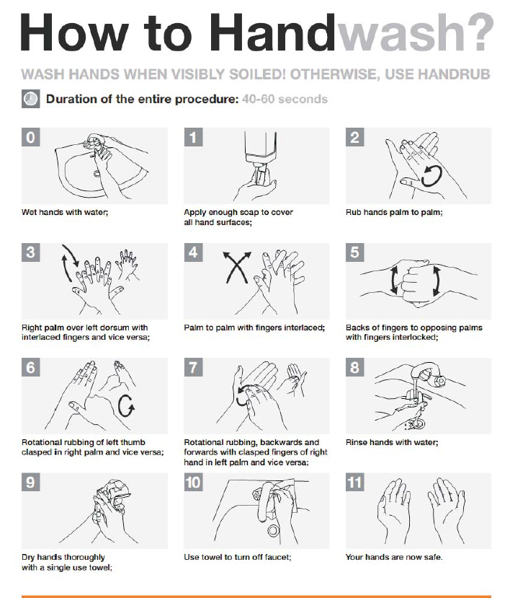

CLASSIFY A NEWBORN BABY AS WELL / UNWELL AND DECIDE ON APPROPRIATE CARE



Neonatal resuscitation

